CONFIGURATION GUIDE

<Configuration jCoreUI document for DEV>

*<JITS>*

*Version 1.0*

*11/2021*

|  |  |  |  |
| --- | --- | --- | --- |
| **Maker** | Signature |  | ________________ |
|  |  |  |
| Full name | VU VAN DUONG | Date |
|  |  |  |
| Position | DEVELOPER | 02/11/2021 |
|  |  |  |
|  |  |  | |
|  |  |  | |
| **Reviewer** |  |  | |
|  |  | |
| Signature | ________________________ | ________________ |
|  |  |  |
| Full name |  |  |
|  |  |  |
| Position |  |  |
|  |  | |
|  |  |  |  |

**DOCUMENT REGISTER**

|  |  |
| --- | --- |
| Title | Configuration jCoreUI document for DEV |
| Code | JITS |
| Author | JITS |
| Version | 1.0 |
| Create date | 02/11/2021 |
| Modify date |  |

**VERSION HISTORY**

|  |  |  |  |  |  |
| --- | --- | --- | --- | --- | --- |
| Version | Maker | Make date | Reviewer | Review date | Document changes |
| 1.0 | DuongVV | 02/11/2021 |  |  | Create document |

Warning: This document is protected by copyright law and international treaties. No part of this document may be reproduced or transmitted in any form or by any means, electronic or mechanical, for any purpose, without the express written permission of JITS. Unauthorized reproduction or distribution of this presentation or any portion of it, may result in severe civil and criminal penalties, and will be prosecuted to the maximum extent possible under applicable law. Information in this document is subject to change without notice

Contents

1. CONFIG MENU 5

2. MENU PERMISSIONS 7

3. CONFIG FORM SEARCH 9

4. CONFIG DYNAMIC FORM 10

5. CONFIG LOOKUP DATA 12

6. CONFIG GET INFO DATA 13

# CONFIG MENU

* Step 1: Open database and open table UI_MENU

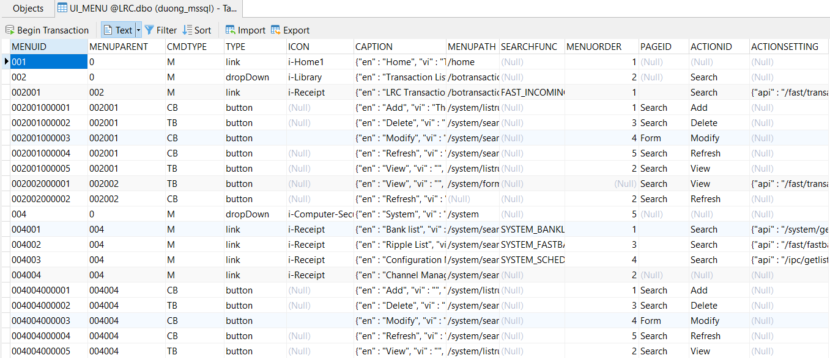

Details:

|  |  |  |
| --- | --- | --- |
| Column name | Description | Example |
| MENUID | Id of menu  Note: ID of the menu is classified by level: 3 number is a level | 001 |
| MENUPARENT | Id of parent menu | 0 |
| CMDTYPE | Type of menu | * M: Menu * CB: Button on Combo box * TB: Button on table |
| TYPE | Type of control | * link: link to a page * button: button on form * dropDown: parent of other menu |
| ICON | Icon will show on UI | i-Receipt |
| CAPTION | Caption show on UI. Must be JSON string have key: en, vi, kh | {"en" : "Home", "vi" : "Trang chủ", "kh" : "ទាំងគ្រប់គ្រង"} |
| MENUPATH | Path from URL to show form of menu | /home |
| SEARCHFUNC | Search function of form. To display table search. Stored on table S_SEARCH | SYSTEM_BANKLIST |
| MENUORDER | Order number of menu. Greater than 0 | 1 |
| PAGEID | Type of page display it | * Null: is menu * Search: in search form * Form: in add or view form |
| ACTIONID | Action of menu | * Null: is menu * Search: is search form * Others: Add, View, Modify,… is button |
| ACTIONSETTING | Api path of menu. It will call when click menu | {"api" : "/system/getlistbank"} |

* Step 2: Logout and login again

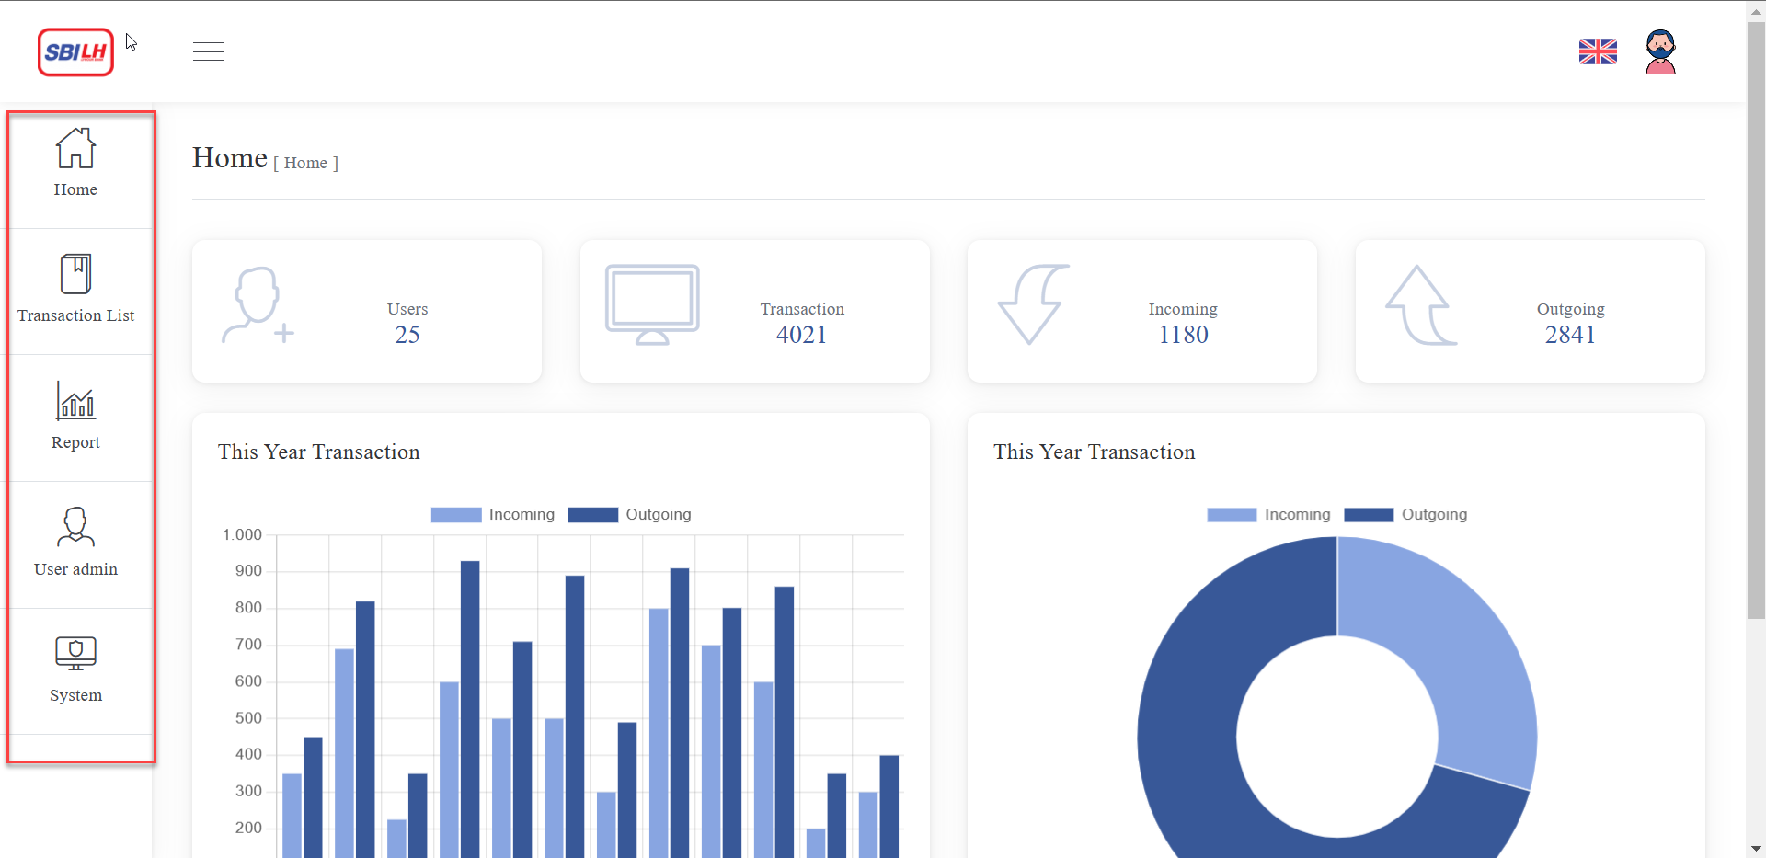

Figure 1: Display menu

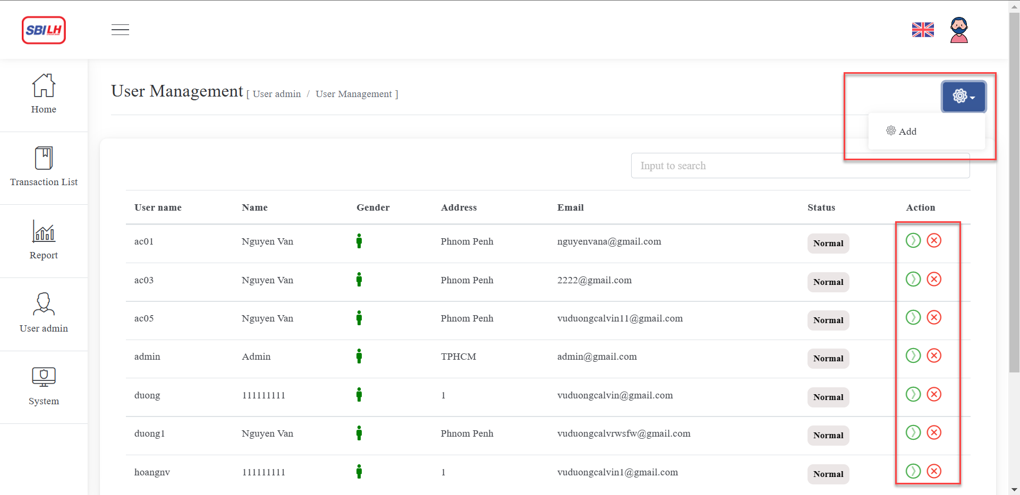

Figure 2: Button on Search form

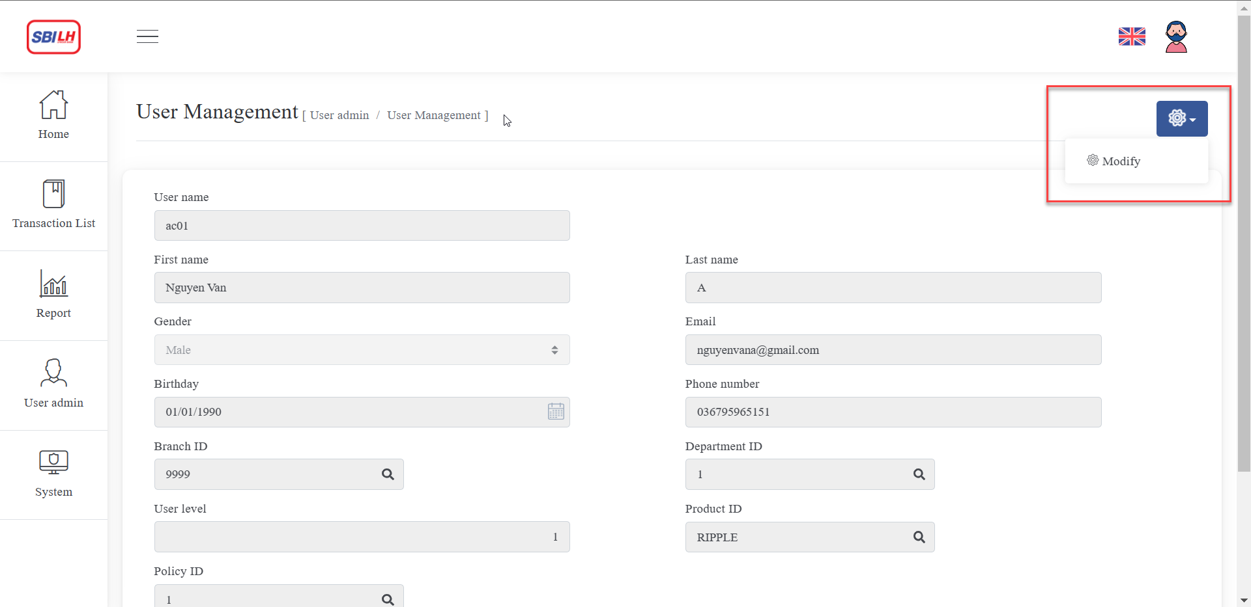

Figure 3: Button on View form

# MENU PERMISSIONS

* Step 1: Go to table S_USRAC to choose user and get username

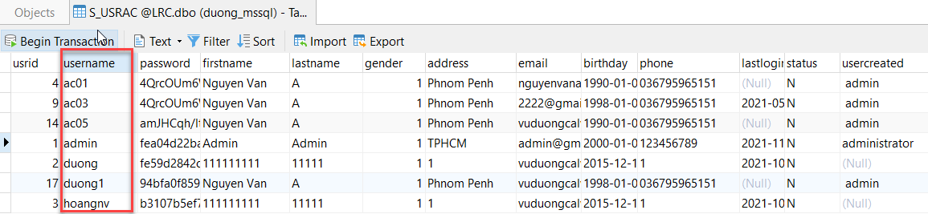

* Step 2: Go to table S_USERROLE to choose role for user. Get roleid

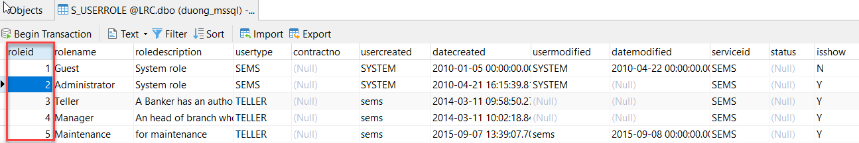

* Step 3: Go to table S_ USERROLE insert new role

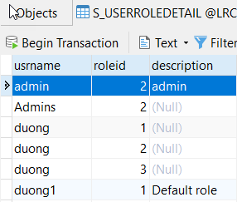

Details:

|  |  |  |
| --- | --- | --- |
| Column name | Description | Example |
| usrname | Username of user | admin |
| roleid | Id of role | 2 |
| description | Description of role |  |

* Step 4: Go to table S_ MENUROLE insert new role

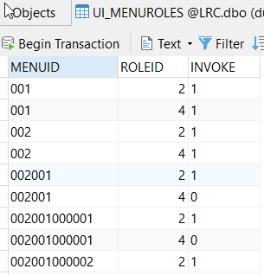

Details:

|  |  |  |
| --- | --- | --- |
| Column name | Description | Example |
| MENUID | ID of menu | 001 |
| ROLEID | ID of role | 2 |
| INVOKE | 1 is enable  0 to disable | 1 |

# CONFIG FORM SEARCH

* Step 1: Config Search name on UI_MENU:

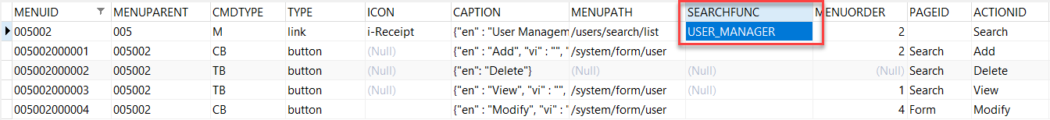

* Step 2: Config S_Search:

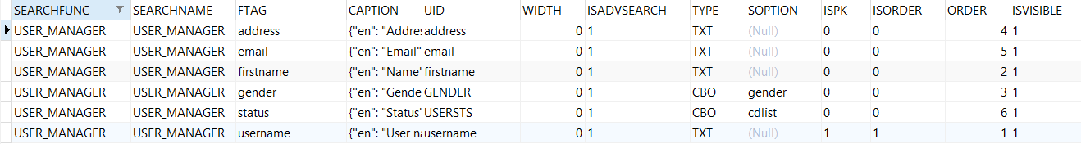

Details:

|  |  |  |
| --- | --- | --- |
| Column name | Description | Example |
| SEARCHFUNC | Search ID | USER_MANAGER |
| SEARCHNAME | Search name | USER_MANAGER |
| FTAG | ID of field | username |
| CAPTION | Caption to display | {"en": "User name", "vi": "Tên đăng nhập", "kh": ""} |
| UID | ID to get data | username |
| WIDTH | No use | 0 |
| ISADVSEARCH | Config this field display on advanced search | 1 |
| TYPE | Type of control | CBO: combobox  TXT: Text field |
| SOPTION | Source data to load to combobox | cdlist |
| ISPK | Is primary key | 1 |
| ISORDER | Is order by this field | 1 |
| ORDER | Order number | 1 |
| ISVISIBLE | Is visible | 1 |

Result:

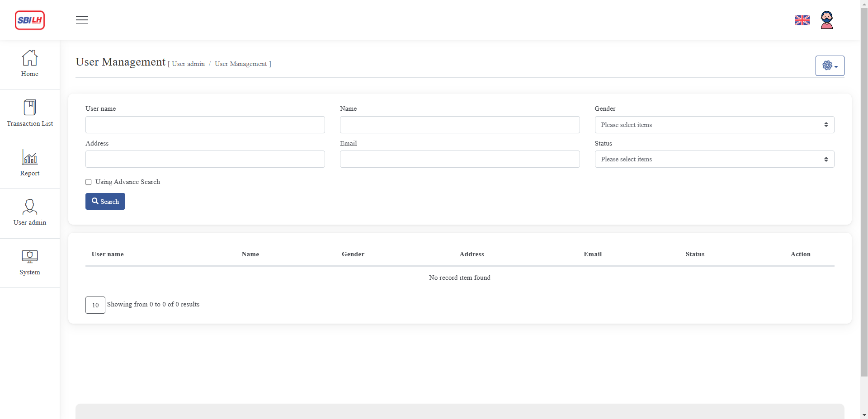

# CONFIG DYNAMIC FORM

Dynamic form is Add or View form

* Step 1: Config menu in UI_MENU



Note: ACTIONSETTING have 3 key api, path, formname. Example: {"api" : "/user/adduser", "path": "/system/form/user", "formname": "USER_MANAGER"}

* + api: path of API
  + path: path of form
  + formname: name of form, is key in table S_FORM
* Step 2: Config form in S_FORM

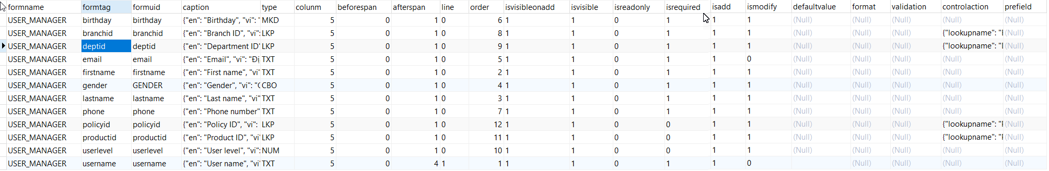

Details:

|  |  |  |
| --- | --- | --- |
| Column name | Description | Example |
| formname | ID of form | USER_MANAGER |
| formtag | Tag of field in form | username |
| formuid | UID of field in form | username |
| caption | Caption to display | {"en": "User name", "vi": "Tên đăng nhập", "kh": ""} |
| type | Type of control | * TXT: Text field * CBO: Combo box * NUM: Number field * MKD: Mask Date field * LKP: Lookup data field |
| colunm | Width of field in Bootstrap 4 | 5 |
| beforespan |  | 0 |
| afterspan |  | 1 |
| line |  | 0 |
| order | Order number in form | 1 |
| isvisibleonadd | Is visible on form Add | 1 |
| isvisible | Is visible after open form | 1 |
| isreadonly | Is no enable | 0 |
| isrequired | Is require | 1 |
| isadd | Is allow to add | 1 |
| ismodify | Is allow to modify | 0 |
| defaultvalue | Default value of field |  |
| format |  |  |
| validation |  |  |
| controlaction | Action of field Lookup data | {"lookupname": "POLICY_LKP"} |
| prefield |  |  |

Result:

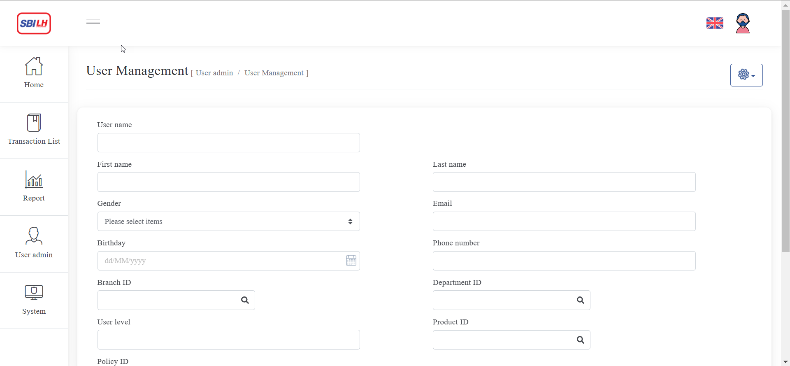

# CONFIG LOOKUP DATA

* **Case 1**: Default
  + Config in table S_LOOKUP

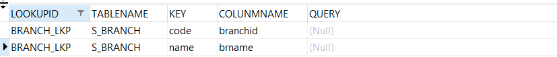

Details:

|  |  |  |
| --- | --- | --- |
| Column name | Description | Example |
| LOOKUPID | ID of Lookup | BRANCH_LKP |
| TABLENAME | Table name stored data | S_BRANCH |
| KEY | Key api reponse to client. | * code: ID or code of data * name: name or description |
| COLUNMNAME | Column name of the table above | branchid |
| QUERY | No use |  |

* **Case 2**: Lookup data with SQL Query
  + Config in table S_LOOKUP



Details:

|  |  |  |
| --- | --- | --- |
| Column name | Description | Example |
| LOOKUPID | ID of Lookup | BANK_LKP |
| TABLENAME | Table name stored data | S_BANK |
| KEY | Key data to select | * param: param will send from api to get data * query: query will excute to select data |
| COLUNMNAME | Key data to replace in the select query | bankid |
| QUERY | Query to select data | SELECT * FROM S_BANK WHERE BANKID = {bankid} |

Example: Client will send key “bankid” with data to api, and api will replace data to “{bankid}” in the query.

# CONFIG GET INFO DATA

* Config in S_GETINFOR



Details:

|  |  |  |
| --- | --- | --- |
| Column name | Description | Example |
| inforid | ID of GetInfo | BANK_LKP |
| key | Table name stored data | * query: query will excute to select data * other: key will replace to query select |
| type | Key of input | * N: Number * C: Character * query: query will excute to select data |
| value | Defaut value or query select  Note: Key to replace must be lowercase. Example: {branchid} | * 9999 * SELECT BRNAME, ADDRESS FROM S_BRANCH WHERE BRANCHID = {branchid} AND BRNAME like '%{brname}%' |